FASTA/HTML

Non Reference Genome

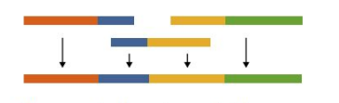

Quality Control Report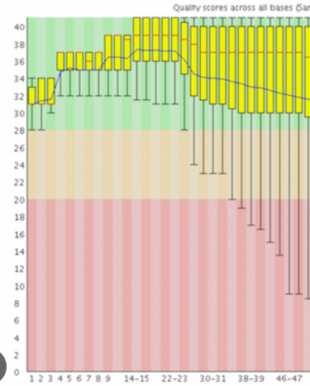 File)

Raw Data (FASTQ)



https://hackmd.io/@GqOnlbqgSdKAMwgCUU_ljQ/rJQDt4EPh

Artificial Intelligence and Expert System Model



1. **Git**
2. **Ubuntu**
3. **Python**
4. **Conda**
5. **Bioconda**
6. **Shovill**
7. **Flye**
8. **etc. ete….**

Alignment

FASTA

GTF/GFF

FA

Expected Results without Querying Db

Model Training Phase

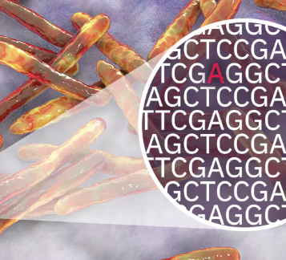

Resistance Genes

Query Database NCBI/ENA/etc.

Assembly

Trimming (FASTQ)

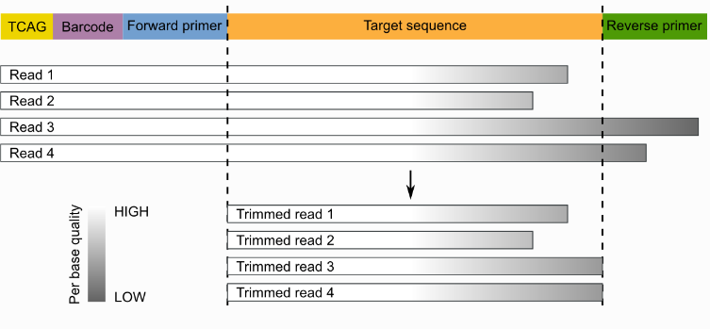

SAM/BAM files

(Reference Genome)

